Interface Fact Sheet

# Interface Details

|  |  |
| --- | --- |
| **Interface Name** | Prophix |
| **Developer** | Manish Gautam |
| **Project** | BEAM Integrations |
| **Date Created** | June 29, 2023 |
| **Date Updated** |  |
| **Interface Status (Active/Inactive)** | Active (To be Deployed to Production) |
| **Interface version** | Concur v1.0 |
| **Exposed as API or Listener** | N |
| **Frequency of Run** | Event Based, Real Time |
| **Business Owner** |  |
| **Data Owner** |  |

Note: Please add this fact sheet to an Integration Factsheets folder in SharePoint and provide this as a resource on Interface Factsheet.

# Requirement

Design integration to receive Concur dropped files from SFTP to Viewpoint (TC1). Trimble users would require these data for revenue forecast. Cozyroc+SSIS package acts as a middleware.

# Integration Design

Process Flow: Interface establishes an SSH connection with BIRD Azure SFTP using a key pair authentication and checks for new files on the location dropped by Prophix. These files contain Forecast Revenue Data. There would be different folder (PFR1, PFR2, PFR3, PFR4,……….) for different files on Azure SFTP and the file would be dropped in their respective folder. The request is sent to import new files from each specific folder to a staging folder in Trimble’s shared location. Once these files are renamed and moved to SMB shared folder then Vista auto picks the file to insert data into Vista DB.

Business Logic and validation:

1. Prophix drops file on BIRD Azure SFTP to its specific folder. (PFR1, PFR2, PFR3, PFR4,……….)

2. Prophix SSIS package checks for the new file on SFTP location and imports file to a staging folder.

3. The package then renames and moves the file to a its specific pickup folder on SMB shared location with name as -------------- .

4. Vista auto pickup integration then picks the renamed file from SMB share from each of the folder and uploads to the Vista DB as well as archives it.

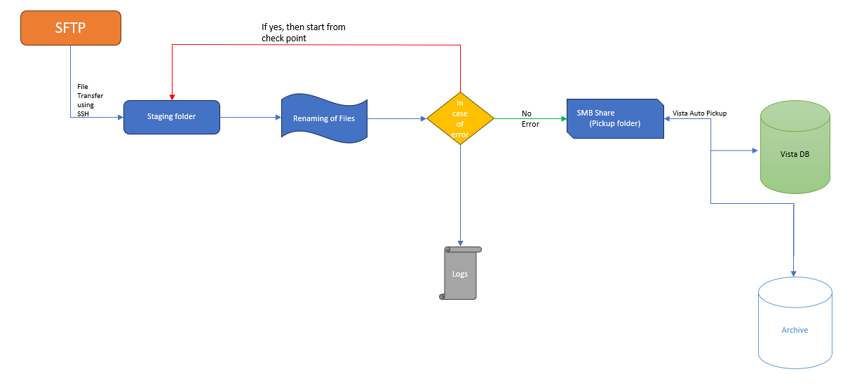

**Error Handling configurations**

Any error in the flow will be captured in the log file. It will capture error description along with messages mapped to a canonical message structure and logged to the common error handling queue.

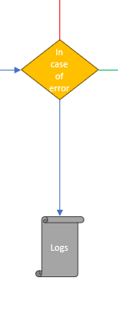

# Source and Destination Design

Data is received from SFTP by establishing SSH connection. Once connection is established the SSIS package will receive files and send it to SMB staging folder.

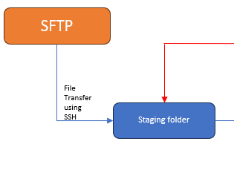

|  |  |  |  |
| --- | --- | --- | --- |
| **Environment** | **Source Server** | **Connection Details** | **Destination Server** |
| DEV |  | Cozyroc SSH |  |
| TEST | stbrdtc1sftunwacac01.blob.core.windows.net | Cozyroc SSH | (SMB Share) |
| PROD |  | Cozyroc SSH |  |

# Prophix Configurations specific to this interface

Example: level of DB access required, scheduler setup, polling frequency etc. level of folder permissions at OS (Operating System) level or exchange of any files between servers if required, anything which needs to be considered for the release/deployment plan. Initial data load interface or csv to be loaded before the interface starts.

|  |  |  |
| --- | --- | --- |
| **Connector/Configuration** | **Short Description** | **Specific Values set and purpose** |
| Azure SFTP | Read Write access with authenticated user role is required to fetch the file from SFTP | Auto login with Cozyroc File transfer task when package is initiated. |
| S*MB Share* | Admin access is required to rename and move the files to Vista pickup folder. | Will rename the file in staging folder and move to Vista pickup folder when package is successfully run. |
| Entry in Logs | Admin access is required to write in the logs file. | Pre execute validation till post execution. |

# Error Codes

|  |  |  |
| --- | --- | --- |
| **ERROR CODES** | **DESCRIPTION** | **REMEDIATION** |
|  |  |  |
|  |  |  |
|  |  |  |
|  |  |  |

# Operational Checklist

|  |  |
| --- | --- |
| **Action** | **Pre-requisites** |
| Validation of Execution | Pre and Post execution validation will be captured in logs |